Et billede, der indeholder mønster, kvadratisk, Symmetri, kunst

Indhold genereret af kunstig intelligens kan være forkert.White Bird

**Læremidlet** White Bird – a Wonder story, af R. J. Palacio

**Medietyper** Bog og film

**Fag** Engelsk

[**https://link.mitcfu.dk/m/CFUFH0790051192**](https://link.mitcfu.dk/m/CFUFH0790051192)

**Målgruppe** 7.-10. klasse

**Nøgleord** Fordomme, racisme, forfølgelse, krig, venskab, kærlighed, ungdom, graphic

novels, autentiske tekster, læseforståelse, leg og bevægelse

# 

# Fagligt fokus

Denne pædagogiske vejledning består af en række forslag til at arbejde med den grafiske roman White Bird, men den indeholder også specifikke tasks og opgaver til filmen fra 2023 af samme navn. Fokus vil være på læseforståelse, fortolkning og sammenligning af bog og film, men også legende tilgange til ordforrådstilegnelse og arbejdet med eleverne egne udtryk.

White Bird er en prisbelønnet autentisk graphic novel. En hjertevarm og tankevækkende historie, der er løst tilknyttet romanen Wonder, men som fint kan læses selvstændigt. Historien fokuserer på drengen, som mobbede Auggies og er hans bedstemors fortælling om hendes flugt fra nazisterne under 2. Verdenskrig. Fortællingen centrerer omkring temaer som Discrimination, Racial Prejudice, Survival, Friendship, The Power of Kindness og Against All Odds.

Det er historien om en ung jødisk pige der bliver skjult af en familie i det nazi-besatte Frankrig under starten af ​​2. Verdenskrig, og hvordan den dreng, hun og hendes klassekammerater engang mobbede, bliver hendes redningsmand og bedste ven, og måske endda første kærlighed.

Opgaverne er delt ind i kategorierne før, under og efter læsningen. Formålet med at I arbejder med den vigtige før-forståelse, er at sikre dine elever en fælles forforståelse, som både motiverer dem og introducerer dem til vigtig viden om historiens baggrund og dele af det grundlæggende ordforråd, inden læsningen skal påbegyndes.

Undervejs igennem bogen kan I arbejde med de små opgaver med fokus på sprog og form. Disse opgaver kan bruges som afbræk i læsningen, da jeres læsning af bogen må forventes at foregå over en længere periode.

Efter-læsningsfasen giver mulighed for at arbejde med at forstå og fortolke. Her kan dine elever også udtrykke sig kreativt både skriftligt og mundtligt i form af egne tekster og illustrationer.

Arbejd skiftevis med bogen fælles på klassen og i små grupper, og arbejd med tema, plot og personer samt, hvordan elementerne spiller sammen med grafik og farvevalg. Du kan evt. vælge at arbejde med bogen i forbindelse med et holocaustforløb. Udover bog og film kan du finde en padlet med vigtige ressourcer under ’supplerende materialer’. Her er den nødvendige ressourcer til at skabe en grundlæggelse forforståelse af historien og setting, ordforråd og opgaver/aktiviteter til stilladsering af bogen.

**Ideer til undervisningen**

**Before reading**

**Introducing the book**  
Look at the cover of the book, flip through the book and reflect on the following:

* What do you think the book will be about?
* Do the covers make you want to read the book? If so, why?
* The title “White Bird”. What could it refer to?
* What colours are used in the book?

**Book trailer**

Watch the book trailer below.

* Does it tell us more about the story and the time in which it takes place?

[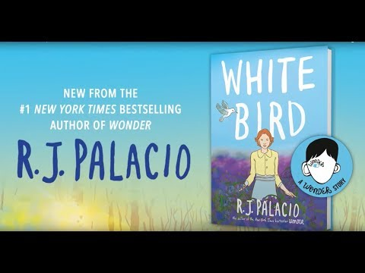](https://www.youtube.com/embed/hG6OCsnEUXE?feature=oembed)

**Introducing vocabulary**

Prepare the learners to read the book by letting them work with vocabulary on Quizlet’s free functions: Flashcard, Learn, Test and Match:

* [White Bird – 34 flashcards with pictures](https://quizlet.com/dk/1024753537/white-bird-flash-cards/?i=h4f4h&x=1jqt)

**Interview**

Listen to an [interview with the author, R J. Palacio,](https://youtu.be/rlWyVoz46vs?si=Z0xC85MoCQ74UnPp) and talk about why she wrote the book?

**During reading**

**Listen to the beginning of the story**

Audio - intro + chapter 1 og 2: <https://www.audiobooks.com/audiobook/360914>

Focus on the areas mentioned below.

The rest of the book can be read in pairs or alone.

**Take notes:**

While you read keep an eye on the following elements and take notes:

* **Colours and the mood:** The use of colour in White Bird is significant; look closely at Palacio’s choices. How does her palette help develop the mood and support the plot? How is it used to enhance descriptions of the characters? Find examples, give your opinion and explain.
* **Symbols and figurative language:** Do you find any reoccurring picture and symbols? What are they symbols of and how to they connect to the story? (The white dove, the blue bells, the wolf etc.)
* **Frames and panels:** How does Palacio use frames and panels in the story and how does it affect the story? What about the first frame in every chapter? How does it forecast what will happen in the chapter?
* **Composition:** How is the story divided into parts and why? Consider the quotes: What do you think they mean?
* **Characters:** How do the characters and their relationships change throughout the story
* **Theme:** What are the main themes and subthemes of the story? How does the persecution of the Jews escalate through the book?
* **Perspective:** Are there any ways Sara’s family is like yours? How are they different? Are there events happening today in the world that could compare to some of the events in the book?
* **Banned books:** A ban has been attempted on White Bird several American states. Why do you think someone would ban this book?

**After the reading**

**Speaking**

Sum up on the notes from the tasks from ‘During the reading’.

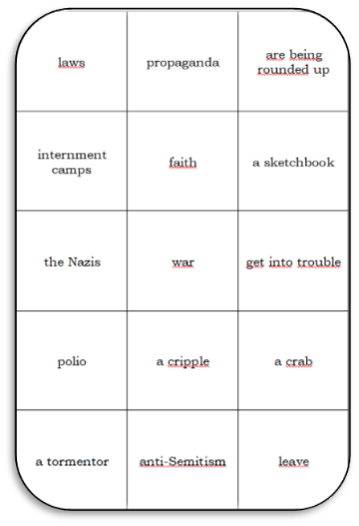**Quiz on Quizizz**

Create an interactive quiz on Quizizz using only a free user. Share this quiz: [Focus on plot, language and theme](https://quizizz.com/admin/quiz/644d2a8095a950001d8c42d0/white-bird) or copy it, choose edit and make it into your own. Find more quizzes on the padlet below under ‘Supplerende materialer’.

**Comprehension questions**

Find more comprehension questions on the padlet under the headline: Understanding the Story

**Vocabulary and oral language activities**

Use the word cards to learn, train and activate vocabulary as well as include movement in the after reading process. Examples: Do a [Watson’s Word Wall](https://www.vildmedengelsk.dk/leg-og-bev%C3%A6gelse/mellemtrin/watsons-word-wall) to retell the story or make statements relevant to the text, make a [Word Race](https://www.vildmedengelsk.dk/leg-og-bev%C3%A6gelse/mellemtrin/word-race) or a [Move Freeze, Speak up](https://www.vildmedengelsk.dk/leg-og-bev%C3%A6gelse/mellemtrin/dance-move-freeze-speak) to explain or translate the slang vocabulary.You can also find the word cards (ordkort) on the padlet below.

**Vocabulary Bingo**

Use this activity to memorize and discuss vocabulary. You can find the link to the game on the padlet below.

**Preparation:** Print out the boards and cards - cut apart the cards. Fold the top of each card over to conceal the answer if a small group of students is playing without a separate caller. Photocopy the bingo plates.

**How to play:** Mix up the cards into a face down pile. Take the top card and read the definition. Take turns if playing without a dedicated caller. Find the term that fits the description on the bingo plate. You may not have the word for every definition.

When you complete a row, column or diagonal, you win.

**Alternative ending using Pixton**

What happens when Julien decides to come back after Sara’s sketch book? How does this change the course of events?

Write a new ending consisting of five pictures in a panel. Use Pixton from skoletube.dk to do so.

**A Poster of Hope**

In White Bird, despite Sara’s feeling at times that all is lost, she is driven by hope. Have students create attractive posters to display their hopes and dreams for the future, consider the use of colours and symbols to illustrate these, as well as the

obstacles they face. Write a journal entry or make a short presentation where you identify the objects or symbols that serve as sources of hope for you or will help you to overcome obstacles.

**Interview project: Learn from Living History**

The graphic novel is framed around a grandmother telling her grandson a story about her childhood for a class project. For this activity, conduct an interview with a partner of an older family member, neighbour, or friend about a transformative experience from their own youth. Before the interview, be sure to create a list of questions you want to ask and bring a way to record their responses. Find ideas for your interview sheet on padlet, **Learn from Living History (Activity 2).**

Roleplay the interview with a partner in English in class or create a short story, poem, comic or digital short, or similar that reflects their experience and notes what your generation can learn from it.

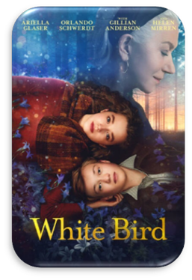

**The Choose Kind Movement**

Check out the Choose Kind Movement online and make a 5-minute presentation of interesting or defining acts of kindness, and how this made a difference in the community.

**Working with the film**

**Before watching the film**

**Film trailer, prediction and video lesson**

Discuss your predictions with a partner before watching the film trailer:

* How do you think the film will be similar to the book?
* How do you think it will be different?

Now watch the trailer on ISL Collective: [White Bird: A Wonder Story general g…: English ESL video lessons](https://en.islcollective.com/english-esl-video-lessons/grammar-practice/general-grammar-practice/present-perfect-simple-tense/white-bird-a-wonder-story/948906), but without doing the tasks.

Now discuss with your partner how the film might be different from the book:

* Do you think the movie and book will be similar? How so?
* How is the mood of the film different from the book? Why has the film director made these changes?
* Do any characters look different than you had imagined in your head?
* What part of the movie are you most excited for?

After watching the trailer, do the tasks of the video lesson.

**After watching the film**

**Character descriptions**

Think of how the characters were portrayed in the movie. What did

they look like. What personality traits did they have? How are these characters different in the movie than in the book?

* Sara Blum
* Julien Beaumier
* Jean-Paul & Vivienne Beaumier
* Vincent
* Rose & Max Blum

**Wenn diagram**

Make a Wenn diagram of the book vs. movie comparing the setting, plot, characters and resolution & ending

**Think, Pair, Share - your opinion**

You can organize this class discussion as a cooperative learning activity. Find a description on Vild med English: [Think-Pair-Share](https://www.vildmedengelsk.dk/leg-og-bev%C3%A6gelse/udskoling/think-pair-share):

* Do you think the movie did a good job following the plot of the book? If not, what did they leave out of the movie?
* Who was your favourite character in the book? What about in the movie? Why?
* Did you prefer the book or the movie? Why?
* How did watching the movie help your understanding of the book?

**Supplerende materialer**

* White Bird, film: <https://link.mitcfu.dk/m/CFUFILM1138508>
* Wonder, film: <https://link.mitcfu.dk/m/CFUFILM1105751>
* Wonder, roman: <https://link.mitcfu.dk/m/45752607>
* Wonder, Penguin Reader: <https://link.mitcfu.dk/m/47087333>

**Andre relevante eksterne links findes på denne padlet:**

<https://padlet.com/lisefenger/whitebird>