Titel  Different Kinds of Love |  | QR-kode fører til posten i mitCFU
Tema: Kærlighed
Fag: Engelsk
Målgruppe: 8.-10.kl.
Data om læremidlet:

Tv-udsendelser :’Different kinds of love’ Kortfilm DR & SV2 TV00000114098

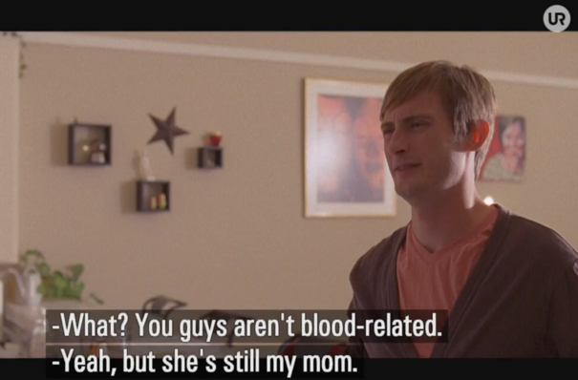

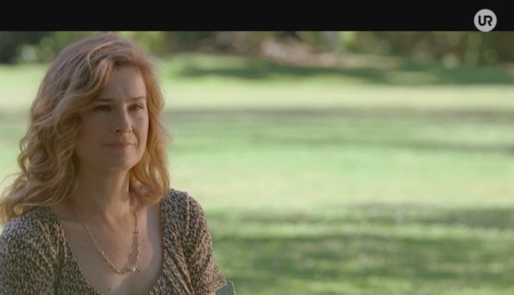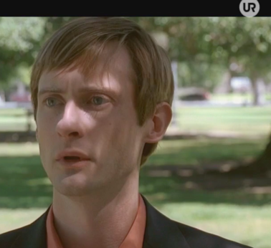
Billederne er fra ’Found’ Kortfilm SVT 2, 19-01-2014 , 20 minutter

Indhold kort
Disse tre kortfilm omhandler vidt forskellige former for kærlighede. Vi møder Greenwood, som lider af en frygtelig stammen og derfor har svært ved at involvere sig i et forhold med en pige. I den anden film er hovedpersonen Mr. Foreman, hvis kærlighedsliv stort set er gået i stå pga. af hans kompleks i forhold til hans manglende hår. Til sidst har vi Alex, som er adopteret. Han vil gerne finde sin biologiske mor, men hans adoptivmor er imod det. Hvem elsker hvem i denne film?

Faglig relevans/kompetenceområder
Denne vejledning indeholder ideer til at arbejde med nedenstående kortfilm før, under og efter at have set filmene:

1: ’Syrup’ kortfilm DR 1, 04-11-2001, 11 minutter
2: ’Stutterer’ Kortfilm SVT 2, 11-09-2016 , 14 minutter
3: ’Found’ kortfilm SVT2, 19-01-2014, 20 minutter

De tre film handler hver især om kærlighed – men helt forskellige former for kærlighed, og dette sættes spot på i vejledningen.

Man kan vælge, om alle elever først ser alle film sammen og derefter i tre grupper arbejder med hver deres film, eller om filmene først ses af alle i slutningen af forløbet.

Vejledningen tager sit udgangspunkt i kompetenceoråderne mundtlig kommunikation fra Forenklede Fælles Mål, hvor eleverne arbejder med temaet biologisk og adopteret kærlighed. Dette tema anvendes i samtalens argumentation. I forhold til kompetenceområdet Kultur & Samfund vidensområdet ’Tekst og medier’ stilles forslag om brug af forskellige medier til multimodal tekstproduktion i fx arbejdet med en digital tidlinjer, der integrerer tekst og billeder.

Ideer til undervisningen
Before you watch

Group 1: ’Stutterer’ before you watch
What do you know about stuttering? You may look up the term on the internet: http://www.asha.org/public/speech/disorders/stuttering.htm (source: American Speech-Language-Hearing Association)

Do you know a person who stutters? Make a list of the problems you can think of for a stutterer. The theme of your film is ‘Love’, try and predict what the film might be about by thinking of the title.

Group 2: ’Syrup’ before you watch
What do you know about Syrup? Look it up on www.dictionary.com How do you like what you read there? The theme of your film is ‘Love’, try and predict what the contents might be about by thinking of the title.

Group 3: ’Found’ before you watch
The theme of your film is ‘Love’ , Predict what the contents might be by thinking of the title ‘Found’.

While you watch

Group 1: ‘Stutterer’ while you watch
Check with your list if Greenwood suffers from any of the problems you stated. Share & discuss.

Group 2: ‘Syrup’ while you watch
Make notes where in the film you can imagine ‘syrup’ (real syrup, figurative sense (overført betydning), something like syrup etc.) Share & discuss.

Group 3: ‘Found’ while you watch
Make notes about what is literally found in the film – has it got anything to do with love?
Share & discuss

After you watch
Group 1: ‘Stutterer’ after you watch Tell the contents of the film in https://www.timetoast.com/ (or Tiky-Toky from Skoletube), (cues: facebook chat,
chat language, snap thoughts, relationship to father, excuses for meeting, the fight, sign language, the final meeting.) You may add pictures to make the timeline multi modal.

Which role does the father have in the film?

If you were going to sum up the film’s message in a short sms – what would you write?

Extra: Study the chat language. What is special about it. Choose a chat and translate it.

Group 2: ‘Syrup’ after you watch Tell the contents of the film in https://www.timetoast.com/ (or Tiky-Toky from Skoletube), (cues: Mr. Foreman and his hair, gang, fear, licking, wife at home, tango, bedtimes routines 1, at the office, magazine, going out, reactions, on the way home, at homew again, dinner + dessert, dancing, bedtime 2). You may add pictures to make the timeline multi modal.

Describe the relationship to his wife before and after the change.

Extra: How does the office treat Mr. Foreman before and after the change. Will his change affect the relaionshipto his employees?

Group 3: ‘Found’ after you watch
Tell the contents of the film in https://www.timetoast.com/ (or Tiky-Toky from Skoletube), (Cues: Alex adopted, family, mother, friends, music, the hidden letter, mom’s reaction, birthmom’s house, friend’s role, birthmom’s reaction, her letter, meeting, the end). You may add pictures to make the timeline multi modal.

Extra: Explain the love between Alex-Linda, Alex-mom, Alex-birthmom.
Write birthmom’s letter to Alex. What does she tell him?
How will the relationship between Alex and his extended family develop? Tell a friend.

Points to discuss
The main character in each film has problems and fears to overcome that requires some bravery. Fill out the table where it is possible for you, and compare these problems to other novels or short stories you have read or other films you have watched. You may also compare to your own life and possible troubles/problems.
When you have filled out the chart where it’s possible, ask a person from another group about the missing information and add that. Discuss in class.
Discuss the different aspects of love each of the three films presented. You may finish off by watching all three films again in class.

 | Greenwood  (‘Stutterer’) | Mr. Foreman  (’Syrup’) | Alex  (‘Found’) | Characters from other novels, short stories or films | Yourself
What is the problem?
Where does the person show bravery?
What is the solution to the problem?

Supplerende materialer
Følgende er forslag til supplerende materialer, der evt. kan lånes på dit lokale CFU:
Kortilm:
Barry’s Bespoke Bakery
Fedtbjerget
Min stammen

