[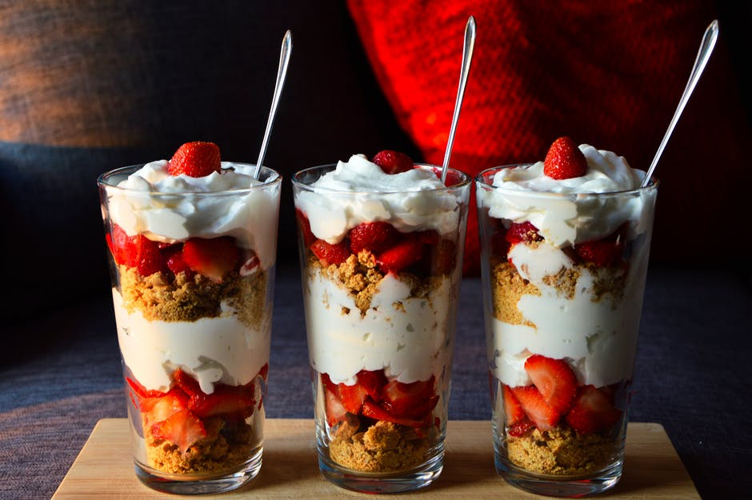](https://static.pexels.com/photos/8382/pexels-photo.jpg)

Dessert

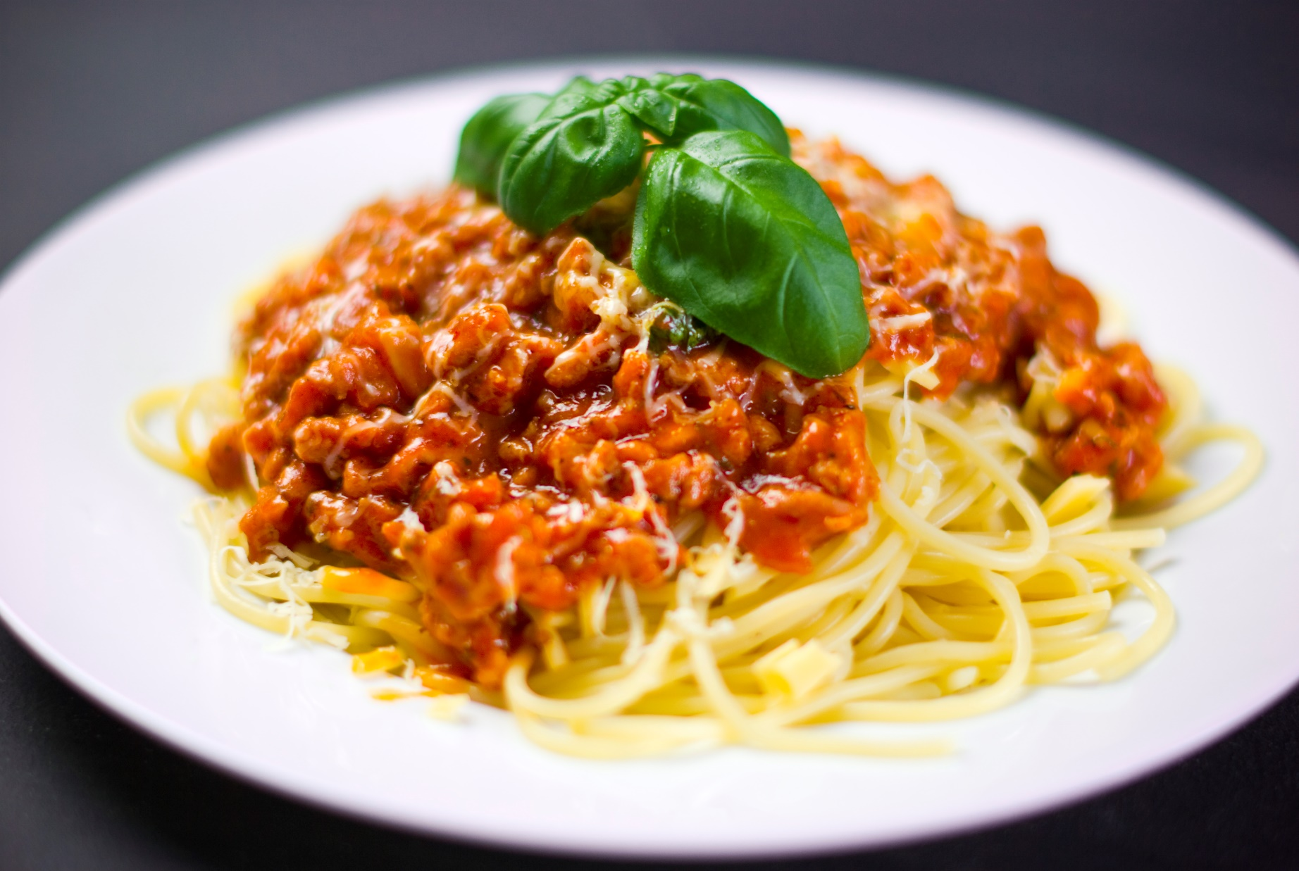 Dinner

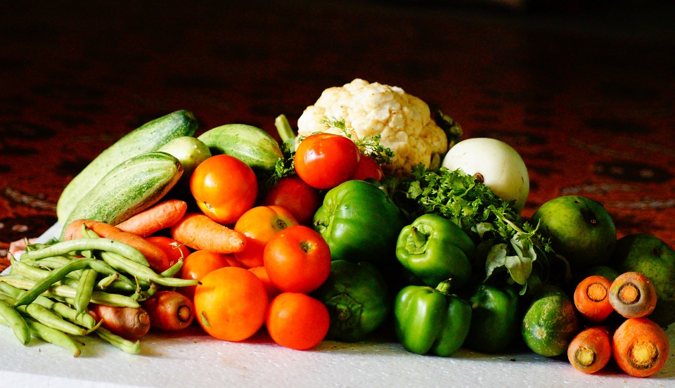

Vegetables